**Procedure to Run from DOS-Prompt**

**Week 01**

**Lab Work**

Press Windows + R button, you will see the following window

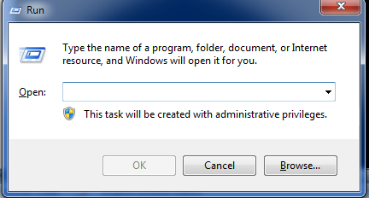

Next type here cmd

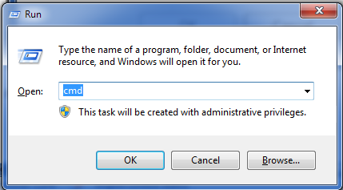

Next, press the OK Button, you will get the following Dos-prompt screen

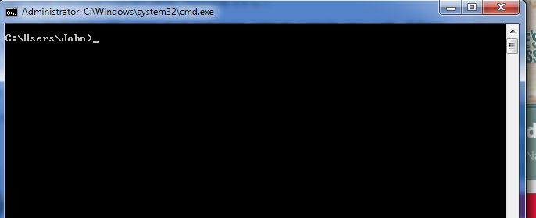

Write **cd..** to go to the C directory

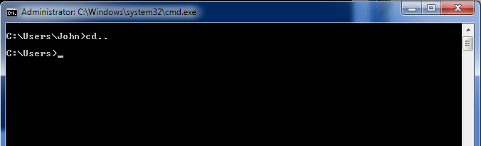

Again Write **cd..** then we will go to the main directory of C

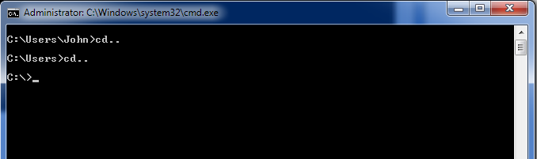

Now you are in c directory just write **cd program files** (cd means= change directory) and **program files** is folder name where java is installed

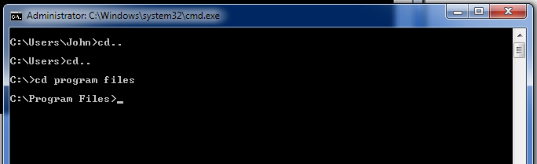

Now write **cd java** ( here also cd is change directory you have to use all the time before folder name like here **java** is folder name )

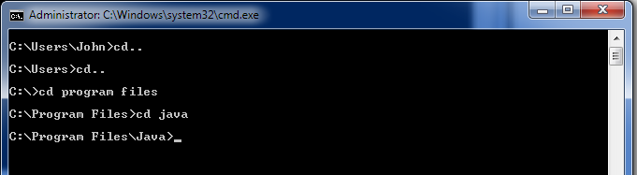

write cd and installed jkd with its version like in the following written

cd jdk-11.0.8 (11.0.8 is the version of the installed JDK)

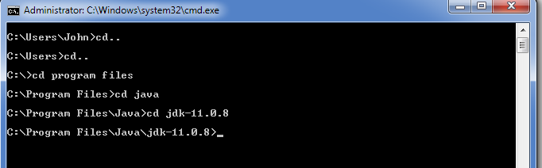

write **cd bin**  because file is saved in bin

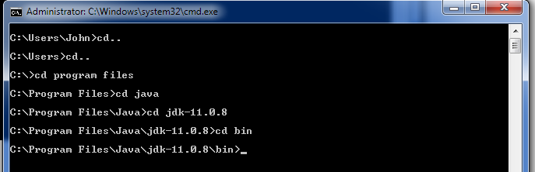

Now, you are in directory where you have Saved the File

Next, we want to compile the code

Type in and PRess the Enter Key

>javac Week02.java

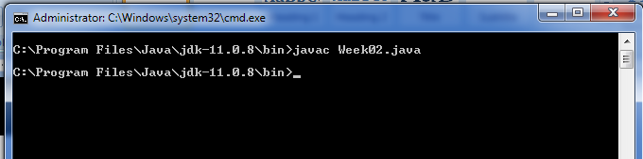

You have successfully compiled the Code

Therefore, Finally, we want to run the code so type in and press the Enter Key

>java Week02

this will show you the output as shwon

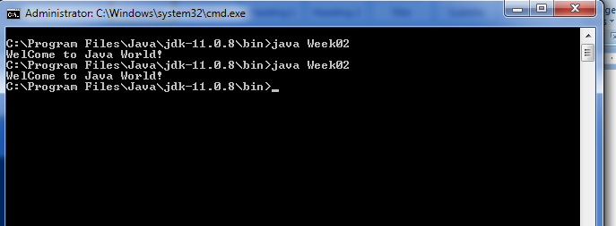

**Program # 1** Write Java Code to Print Wel Come Message on Screen

class Week01

{

public static void main(String[] p)

{

System.out.print("WelCome to Java World!");

}

}

**Program # 2** Write Java Code to declare three numbers

class Week01

{

public static void main(String[] p)

{

int num1;

int num2;

int sum;

System.out.print("WelCome to Java World!");

}

}

**Program # 3** Write Java Code to Print the sum of two integers

class Week01

{

public static void main(String[] p)

{

int num1;

int num2;

int sum;

num1 = 10;

num2 = 90;

sum = num1 + num2;

System.out.print("No1 =" + num1);

System.out.println("No2 =" + num2);

System.out.print("\nSum of Two nos =" + sum);

}

}

**Program # 4** Write Java Code to Print sum of two integers

class Week01

{

public static void main(String[] p)

{

int num1 =10, num2 = 90, sum;

sum = num1 + num2;

System.out.print("No1 =" + num1 + "\nNo2 =" + num2 +

"\nSum of Two nos =" + sum);

}

}

**Program # 5** Write Java Code to Print Arrays

class Week01

{

public static void main(String[] p)

{

System.out.println("Value at Index 0 : " + p[0]);

System.out.println("Value at Index 1 : " + p[1]);

System.out.print("Value at Index 2 : " + p[2]);

}

}

**Program # 6** Write Java Code to read two integers and Print their sum

class Week01

{

public static void main(String[] p)

{

int num1, num2, sum;

num1 = Integer.parseInt(p[0]);

num2 = Integer.parseInt(p[1]);

sum = num1 + num2;

System.out.println("Sum : " + sum);

}

}

**Program # 7** Write Java Code to Print sum of double numbers(floating point)

class Week01

{

public static void main(String[] p)

{

Double num1, num2, sum;

num1 = Double.parseDouble(p[0]);

num2 = Double.parseDouble(p[1]);

sum = num1 + num2;

System.out.println("Sum : " + sum);

}

}

**Program # 7** Write Java Code to Print the sumof two decimals

class Week01

{

public static void main(String[] p)

{

Double num1, num2, sum;

num1 = Double.parseDouble(p[0]);

num2 = Double.parseDouble(p[1]);

sum = num1 + num2;

System.out.println("Sum : " + sum);

}

}

**Program # 9** Write Java Code to Print The percentage of Marks

class Week01

{

public static void main(String[] p)

{

Double totalMarks, obtainMarks, stdPer;

totalMarks= Double.parseDouble(p[0]);

obtainMarks = Double.parseDouble(p[1]);

stdPer= (obtainMarks/totalMarks)*100;

System.out.println("Percentage=: " + stdPer);

}

}

**Program # 10** Write Java Code to Print the grades of students marks

class Week01

{

public static void main(String[] p)

{

Double totalMarks, obtainMarks, stdPer;

totalMarks= Double.parseDouble(p[0]);

obtainMarks = Double.parseDouble(p[1]);

stdPer= (obtainMarks/totalMarks)*100;

//Single line

// > 80 A+

// <80 and >70 A

/*

Comments are very useful for later code understanding

*/

if(stdPer>80)

{

System.out.println("You have A+ Grade" + stdPer);

}

else

{

System.out.println("You have less than A+ Grade"+stdPer);

}

}

}

**Program # 11** Write Java Code to Print the Grades of Students

class Week01

{

public static void main(String[] p)

{

Double totalMarks, obtainMarks, stdPer;

totalMarks= Double.parseDouble(p[0]);

obtainMarks = Double.parseDouble(p[1]);

stdPer= (obtainMarks/totalMarks)*100;

//Single line

// > 80 A+

// <80 and >70 A

/*

Comments are very useful for later code understanding

*/

// <, > =<, >=, ==,<> Relational Operator

//+, -, * , / Arithematic Operator

//&& , ! , || Logical Operator

if(stdPer>=80)

{

System.out.println("You have A+ Grade" + stdPer);

}

else

{

System.out.println("You have less than A+ Grade"+stdPer);

}

}

}

**Program # 12** Write Java Code to read two numbers and Print the Largest number

class Week01

{

public static void main(String[] p)

{

Double firstNumber, secondNumber;

firstNumber = Double.parseDouble(p[0]);

secondNumber= Double.parseDouble(p[1]);

if(firstNumber>secondNumber)

{

System.out.println("First Number is Grater than Second" );

}

else

{

System.out.println("Second Number is grater than First");

}

}

}

**Program # 13** Write Java Code to read the obtain Marks and Total marks and Print the Grades of Students

class Week01

{

public static void main(String[] p)

{

/*

A Grade ==> per>= 80

B Grade <80 and >= 70

C Grade <70 and >= 60

D Grade <60 and >= 50

F Grade <50

*/

Double totalMarks, obtainMarks, stdPer;

totalMarks= Double.parseDouble(p[0]);

obtainMarks = Double.parseDouble(p[1]);

stdPer= (obtainMarks/totalMarks)*100;

if(stdPer>=80)

{

System.out.println("A Grade");

}

else if(stdPer<80 && stdPer>=70)

{

System.out.println("B Grade");

}

else if(stdPer<70 && stdPer>=60)

{

System.out.println("C Grade");

}

else if(stdPer<60 && stdPer>=50)

{

System.out.println("D Grade");

}

else

{

System.out.println("F Grade");

}

}//end of main()

}// end of class

**Program # 14** Write Java Code to read the Numbers and print and print the month

class Week01

{

public static void main(String[] p)

{

/*

A Grade ==> per>= 80

B Grade <80 and >= 70

C Grade <70 and >= 60

D Grade <60 and >= 50

F Grade <50

*/

int numberOfMonth;

numberOfMonth = Integer.parseInt(p[0]);

//obtainMarks = Double.parseDouble(p[1]);

//stdPer= (obtainMarks/totalMarks)*100;

if(numberOfMonth==1)

{

System.out.println("Month Name is January");

}

else if(numberOfMonth==2)

{

System.out.println("Month Name is February");

}

else if(numberOfMonth==3)

{

System.out.println("Month Name is March");

}

else if(numberOfMonth==4)

{

System.out.println("Month Name is April");

}

else if(numberOfMonth==5)

{

System.out.println("Month Name is May");

}

else if(numberOfMonth==6)

{

System.out.println("Month Name is June");

}

else if(numberOfMonth==7)

{

System.out.println("Month Name is July");

}

else if(numberOfMonth==8)

{

System.out.println("Month Name is August");

}

else if(numberOfMonth==9)

{

System.out.println("Month Name is September");

}

else if(numberOfMonth==10)

{

System.out.println("Month Name is October");

}

else if(numberOfMonth==11)

{

System.out.println("Month Name is November");

}

else if(numberOfMonth==12)

{

System.out.println("Month Name is December");

}

else

{

System.out.println("wrong number entered");

}

}//end of main()

}// end of class

**Program # 15** Write Java Code to read the number from user and Print the Seasons

class Week01

{

public static void main(String[] p)

{

/*

A Grade ==> per>= 80

B Grade <80 and >= 70

C Grade <70 and >= 60

D Grade <60 and >= 50

F Grade <50

*/

int numberOfMonth;

numberOfMonth= Integer.parseInt(p[0]);

//obtainMarks = Double.parseDouble(p[1]);

//stdPer= (obtainMarks/totalMarks)*100;

if(numberOfMonth>= 1 && numberOfMonth <=3 )

{

System.out.println("The is Spring Season");

}

else if(numberOfMonth>= 4 && numberOfMonth <=6)

{

System.out.println("This is Summer Season");

}

else if(numberOfMonth>= 7 && numberOfMonth <=9)

{

System.out.println("The is Winter Season");

}

else if(numberOfMonth>= 10 && numberOfMonth <=12)

{

System.out.println("This is Autumn Season");

}

else

{

System.out.println("wrong number entered");

}

}//end of main()

}// end of class

**Program # 16** Write Java Code to Print the number by loop

class Week01

{

public static void main(String[] p)

{

//loops Demo

//counted loops -- no of iterations are known in advance (for loop)

//uncounted/uncontrooled loop no of iterations are not known in advance (while and do while)

int no=6;

for(int i=1;i<=10;i++)

{

System.out.println(no + " X " + i + " = " + (no * i));

}

}//end of main()

}// end of class

**Program # 17** Write Java Code to read the start and end value by loop and Print the odd number b/w them

class Week01

{

public static void main(String[] p)

{

//loops Demo

//counted loops -- no of iterations are known in advance (for loop)

//uncounted/uncontrooled loop no of iterations are not known in advance (while and do while)

// Read a loopStart and loopEnd Value from User and

//then print all odd nos from loopStart to loopEnd

int startVal,endVal;

startVal=Integer.parseInt(p[0]);

endVal=Integer.parseInt(p[1]);

for(int i=startVal;i<=endVal;i++)

{

if(i%2!=0)

{

System.out.println("i = " + i );

}

}

}//end of main()

}// end of class

**Program # 18** Write Java Code to read the start and end value by loop and Print the sum of odd numbers b/w them

class Week01

{

public static void main(String[] p)

{

//loops Demo

//counted loops -- no of iterations are known in advance (for loop)

//uncounted/uncontrooled loop no of iterations are not known in advance (while and do while)

// Read a loopStart and loopEnd Value from User and

//then print all odd nos from loopStart to loopEnd

int startVal,endVal,sum=0;

startVal=Integer.parseInt(p[0]);

endVal=Integer.parseInt(p[1]);

for(int i=startVal;i<=endVal;i++)

{

if(i%2!=0)

{

sum=sum+i;

}

}

System.out.println("sum = " + sum );

}//end of main()

}// end of class

**Program # 19** Write Java Code to read the number and print the factorial of that number

class Week01

{

public static void main(String[] p)

{

//loops Demo

//counted loops -- no of iterations are known in advance (for loop)

//uncounted/uncontrooled loop no of iterations are not known in advance (while and do while)

// Read a loopStart and loopEnd Value from User and

//then print all odd nos from loopStart to loopEnd

int number,factorial=1;

number=Integer.parseInt(p[0]);

for(int i=number;i>0;i--)

{

factorial=factorial*i;

}

System.out.println("factorial= " + factorial );

}//end of main()

}// end of class

**Outputs:**

Microsoft Windows [Version 10.0.19043.1766]

(c) Microsoft Corporation. All rights reserved.

C:\Users\dell>cd..

C:\Users>cd..

C:\>cd program files

C:\Program Files>cd java

C:\Program Files\Java>cd jdk-18.0.1

The system cannot find the path specified.

C:\Program Files\Java>cd jdk-18.0.2

The system cannot find the path specified.

C:\Program Files\Java>cd jdk-18.0.1.1

C:\Program Files\Java\jdk-18.0.1.1>cd bin

C:\Program Files\Java\jdk-18.0.1.1\bin>javac Week01.java

C:\Program Files\Java\jdk-18.0.1.1\bin>java Week01

WelCome to Java World!

C:\Program Files\Java\jdk-18.0.1.1\bin>javac Week01.java

Week01.java:4: error: cannot find symbol

public static void main(string[] p)

^

symbol: class string

location: class Week01

1 error

C:\Program Files\Java\jdk-18.0.1.1\bin>javac Week01.java

C:\Program Files\Java\jdk-18.0.1.1\bin>java Week01

WelCome to Java World!

C:\Program Files\Java\jdk-18.0.1.1\bin>javac Week01.java

C:\Program Files\Java\jdk-18.0.1.1\bin>java Week01

No1 =10No2 =90Sum of Two nos =100

C:\Program Files\Java\jdk-18.0.1.1\bin>java Week01

No1 =10No2 =90Sum of Two nos =100

C:\Program Files\Java\jdk-18.0.1.1\bin>java Week01

No1 =10No2 =90Sum of Two nos =100

C:\Program Files\Java\jdk-18.0.1.1\bin>

C:\Program Files\Java\jdk-18.0.1.1\bin>javac Week01.java

C:\Program Files\Java\jdk-18.0.1.1\bin>java Week01

No1 =10

No2 =90

Sum of Two nos =100

C:\Program Files\Java\jdk-18.0.1.1\bin>javac Week01.java

C:\Program Files\Java\jdk-18.0.1.1\bin>java Week01

No1 =10

No2 =90

Sum of Two nos =100

C:\Program Files\Java\jdk-18.0.1.1\bin>javac Week01.java

C:\Program Files\Java\jdk-18.0.1.1\bin>java Week01

No1 =10No2 =90

Sum of Two nos =100

C:\Program Files\Java\jdk-18.0.1.1\bin>javac Week01.java

C:\Program Files\Java\jdk-18.0.1.1\bin>java Week01

No1 =10

No2 =90

Sum of Two nos =100

C:\Program Files\Java\jdk-18.0.1.1\bin>javac Week01.java

C:\Program Files\Java\jdk-18.0.1.1\bin>java Week01

No1 =10

No2 =90

Sum of Two nos =100

C:\Program Files\Java\jdk-18.0.1.1\bin>java Week01 78 675

No1 =10

No2 =90

Sum of Two nos =100

C:\Program Files\Java\jdk-18.0.1.1\bin>javac Week01.java

C:\Program Files\Java\jdk-18.0.1.1\bin>java Week01 354 Saif MCS

354SaifMCS

C:\Program Files\Java\jdk-18.0.1.1\bin>

C:\Program Files\Java\jdk-18.0.1.1\bin>javac Week01.java

C:\Program Files\Java\jdk-18.0.1.1\bin>java Week01 Saif MCS BIMS

SaifMCSBIMS

C:\Program Files\Java\jdk-18.0.1.1\bin>javac Week01.java

C:\Program Files\Java\jdk-18.0.1.1\bin>java Week01 Saif MCS BIMS

Saif

MCS

BIMS

C:\Program Files\Java\jdk-18.0.1.1\bin>javac Week01.java

C:\Program Files\Java\jdk-18.0.1.1\bin>java Week01 Saif MCS BIMS

Value at Index 0 : Saif

Value at Index 0 : MCS

Value at Index 0 : BIMS

C:\Program Files\Java\jdk-18.0.1.1\bin>javac Week01.java

C:\Program Files\Java\jdk-18.0.1.1\bin>java Week01 Saif MCS BIMS

Value at Index 0 : Saif

Value at Index 1 : MCS

Value at Index 2 : BIMS

C:\Program Files\Java\jdk-18.0.1.1\bin>javac Week01.java

C:\Program Files\Java\jdk-18.0.1.1\bin>java Week01 89 76

Sum : 8976

C:\Program Files\Java\jdk-18.0.1.1\bin>javac Week01.java

Week01.java:8: error: incompatible types: String cannot be converted to int

num1 = p[0];

^

Week01.java:10: error: incompatible types: String cannot be converted to int

num2 = p[1];

^

2 errors

C:\Program Files\Java\jdk-18.0.1.1\bin>javac Week01.java

C:\Program Files\Java\jdk-18.0.1.1\bin>java Week01 89 7

Sum : 96

C:\Program Files\Java\jdk-18.0.1.1\bin>java Week01 89 7 98 65 43 9

Sum : 96

C:\Program Files\Java\jdk-18.0.1.1\bin>javac Week01.java

C:\Program Files\Java\jdk-18.0.1.1\bin>java Week01 89.76 54.33

Sum : 144.09

C:\Program Files\Java\jdk-18.0.1.1\bin>java Week01 89.76 54.33

Sum : 144.09

C:\Program Files\Java\jdk-18.0.1.1\bin>javac Week01.java

Week01.java:6: error: ';' expected

Double Total_marks, Obtain_marks, Per

^

Week01.java:8: error: not a statement

Total_marks, = Double.parseDouble(p[0]);

^

Week01.java:8: error: ';' expected

Total_marks, = Double.parseDouble(p[0]);

^

Week01.java:10: error: not a statement

Obtain_marks, = Double.parseDouble(p[1]);

^

Week01.java:10: error: ';' expected

Obtain_marks, = Double.parseDouble(p[1]);

^

Week01.java:14: error: illegal start of expression

System.out.println("Percentage= : " + Per= );

^

6 errors

C:\Program Files\Java\jdk-18.0.1.1\bin>javac Week01.java

Week01.java:6: error: ';' expected

Double Total_marks, Obtain_marks, Per

^

Week01.java:8: error: not a statement

Total_marks, = Double.parseDouble(p[0]);

^

Week01.java:8: error: ';' expected

Total_marks, = Double.parseDouble(p[0]);

^

Week01.java:10: error: not a statement

Obtain_marks, = Double.parseDouble(p[1]);

^

Week01.java:10: error: ';' expected

Obtain_marks, = Double.parseDouble(p[1]);

^

5 errors

C:\Program Files\Java\jdk-18.0.1.1\bin>javac Week01.java

C:\Program Files\Java\jdk-18.0.1.1\bin>1200 12

'1200' is not recognized as an internal or external command,

operable program or batch file.

C:\Program Files\Java\jdk-18.0.1.1\bin>javac Week01.java\

error: invalid flag: Week01.java\

Usage: javac <options> <source files>

use --help for a list of possible options

C:\Program Files\Java\jdk-18.0.1.1\bin>javac Week01.java

C:\Program Files\Java\jdk-18.0.1.1\bin>javac Week01.java

C:\Program Files\Java\jdk-18.0.1.1\bin>java Week01 89.76 54.33

Percentage=: 60.528074866310156

C:\Program Files\Java\jdk-18.0.1.1\bin>java Week01 820 1100

Percentage=: 134.14634146341464

C:\Program Files\Java\jdk-18.0.1.1\bin>java Week01 89.76 54.33

Percentage=: 60.528074866310156

C:\Program Files\Java\jdk-18.0.1.1\bin>javac Week01.java

C:\Program Files\Java\jdk-18.0.1.1\bin>java Week01 1100 820

Percentage=: 74.54545454545455

C:\Program Files\Java\jdk-18.0.1.1\bin>java Week01 1100 820

Percentage=: 74.54545454545455

C:\Program Files\Java\jdk-18.0.1.1\bin>javac Week01.java

C:\Program Files\Java\jdk-18.0.1.1\bin>java Week01 1100 820

You have less than A+ Grade

C:\Program Files\Java\jdk-18.0.1.1\bin>javac Week01.java

C:\Program Files\Java\jdk-18.0.1.1\bin>java Week01 1100 820

You have less than A+ Grade74.54545454545455

C:\Program Files\Java\jdk-18.0.1.1\bin>javac Week01.java

Week01.java:8: error: not a statement

firstNumber, Double.parseDouble(p[0]);

^

Week01.java:8: error: ';' expected

firstNumber, Double.parseDouble(p[0]);

^

Week01.java:10: error: not a statement

secondNumber;= Double.parseDouble(p[1]);

^

Week01.java:10: error: illegal start of expression

secondNumber;= Double.parseDouble(p[1]);

^

4 errors

C:\Program Files\Java\jdk-18.0.1.1\bin>javac Week01.java

C:\Program Files\Java\jdk-18.0.1.1\bin>java Week01 20 50

Second Number is grater than First

C:\Program Files\Java\jdk-18.0.1.1\bin>java Week01 20.87 50.9

Second Number is grater than First

C:\Program Files\Java\jdk-18.0.1.1\bin>

C:\Program Files\Java\jdk-18.0.1.1\bin>javac Week01.java

Week01.java:53: error: class, interface, enum, or record expected

}

^

1 error

C:\Program Files\Java\jdk-18.0.1.1\bin>javac Week01.java

C:\Program Files\Java\jdk-18.0.1.1\bin>java Week01 1100 870

B Grade

C:\Program Files\Java\jdk-18.0.1.1\bin>javac Week01.java 5

error: invalid flag: 5

Usage: javac <options> <source files>

use --help for a list of possible options

C:\Program Files\Java\jdk-18.0.1.1\bin>javac Week01.java

C:\Program Files\Java\jdk-18.0.1.1\bin>java Week01 7

Month Name is July

C:\Program Files\Java\jdk-18.0.1.1\bin>java Week01 17

Month Name is December

C:\Program Files\Java\jdk-18.0.1.1\bin>javac Week01.java

C:\Program Files\Java\jdk-18.0.1.1\bin>java Week01 17

wrong number entered

C:\Program Files\Java\jdk-18.0.1.1\bin>